CHEMICALBONDING
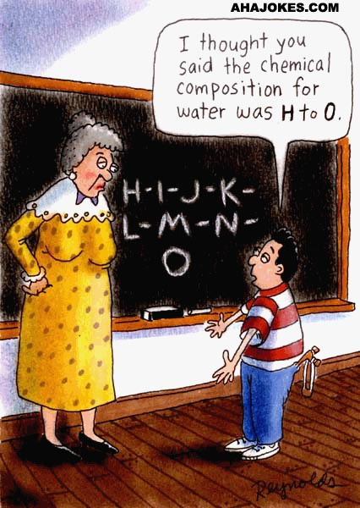

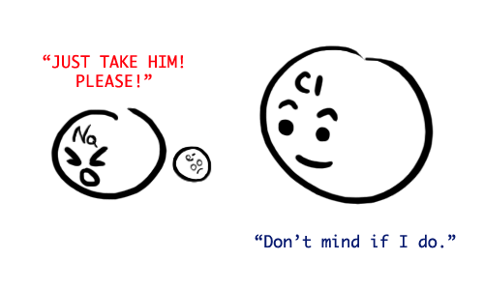

Textbook Chapters 7 & 8
Homework Packet Due: ______________________
Exam Dates: Free Response: _____________________
Multiple Choice: _____________________

Looking Ahead:
Quarterly Exam- Free Response: __________________
Quarterly Exam- Multiple Choice: ________________

CHEMICAL BONDING STUDY GUIDE
UNDERSTANDING THE TYPES OF BONDS WITHIN A SUBSTANCE WILL HELP DESCRIBE ATOMS AND COMPOUNDS IN TERMS OF PHYSICAL AND CHEMICAL PROPERTIES.
- OCTET RULE: ATOMS WILL LOSE, GAIN, OR SHARE ELECTRONS IN ORDER TO ACQUIRE A FULL SET OF EIGHT VALENCE ELECTRONS (THE STABLE ELECTRON CONFIGURATION OF A NOBLE GAS. EXCEPTION TO THE RULE IS HELIUM AND HYDROGEN.
- TYPES OF BONDING :
METALLIC | IONIC | COVALENT
Attraction of a metallic cation for delocalized electrons  Metal with metal | Electrostatic force that holds oppositely charged particles together in a substance.  Metal with nonmetal | A chemical bond that results from the sharing of valence electrons.  Nonmetal with nonmetal
Properties:  - good conductors of heat & electricity  - malleable and ductile  - luster | Properties:  - Usually will have high melting point.  - form very distinct 3-D  crystal shapes  - generally hard and brittle  - In the liquid state or when dissolved in water-can conduct electricity. | Properties:  - Usually will have low melting point.  - do not conduct electricity  - In the solid state covalent compounds tend to be softer then ionic compounds.
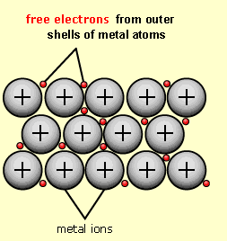 | 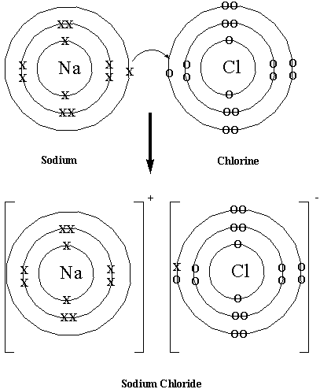 | 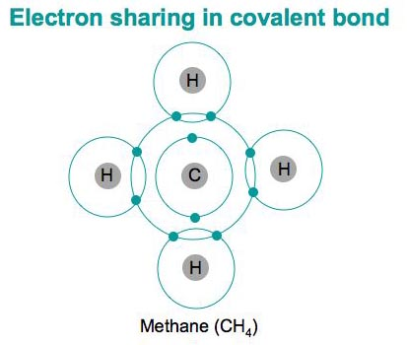

- COVALENT BONDING CAN BE FURTHER CLASSIFIED.
  - POLARITY: Electronegativity determines whether a molecule is either nonpolar or polar. Electronegativity is a measure of an atom's attraction for electrons in the covalent bond
POLAR BOND: When two atoms with different electronegativities are covalently bonded, the atom with the higher electronegativity will attract the shared electrons stronger than the atom with lower electronegativity.
NONPOLAR BOND: Two atoms are covalently bonded with similar electronegativities. There is equal sharing or pull of electrons.
POLAR MOLECULE NONPOLAR MOLECULE
S N A P
SYMMETRICAL NONPOLAR ASYMMETRICAL POLAR

  - SINGLE, DOUBLE (O₂), AND TRIPLE (N₂) BONDING
  - NETWORK SOLIDS…EXAMPLE DIAMOND AND QUARTZ
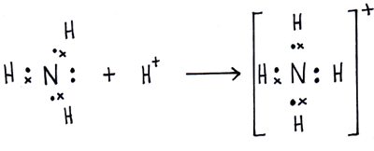
  - COORDINATE COVALENT BONDING
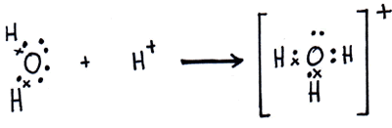

  - INTERMOLECULAR FORCES OF ATTRACTION
FORCES OF ATTRACTION EXIST BETWEEN MOLECULES. THESE FORCES ACCOUNT FOR THE EXISTENCE OF MOLECULAR SOLIDS AND LIQUIDS.
DIPOLE-DIPOLE | HYDROGEN BONDING | LONDON FORCES  (VAN DER WAALS) | MOLECULE- ION
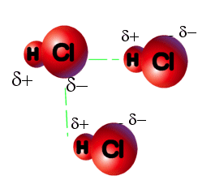 | 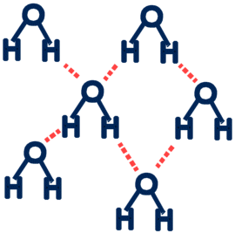 | 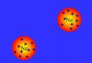 | 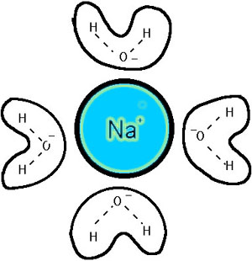
BETWEEN POLAR MOLECULES | HYDROGEN JUST WANT TO HAVE “FON” | BETWEEN NONPOLAR MOLECULES | BETWEEN IONIC AND POLAR MOLECULE

Vocabulary:

BOND ENERGY
OCTET RULE
VALENCE ELECTRONS
IONIC BONDING
IONIC CHARACTER
COVALENT BONDING
MOLECULAR SUBSTANCES
MOLECULE SHAPES
LINEAR BENT
PYRAMIDAL
TETRAHEDRAL
COORDINATE COVALENT
NETWORK SOLIDS
METALLIC BONDING
POLAR BOND
NONPOLAR BOND
IONIZATION ENERGY
ELECTRONEGATIVITY
LEWIS DOT STRUCTURE
SINGLE BOND
DOUBLE BOND
TRIPLE BOND
LONE PAIR ELECTRONS
VALENCE SHELL ELECTRON PAIR REPULSION (VSEPR)
INTERMOLECULAR FORCES OF ATTRACTION
DIPOLE-DIPOLE
HYDROGEN BONDING
VAN DER WAALS (LONDON FORCES)
MOLECULE-ION

BONDING HOMEWORK

Part I-Ionic Bonding
Using the glossary in your textbook, define ionic bonding.
______________________________________________________________________________________

______________________________________________________________________________________

Page 199

#2 ____________________________________________________________________________________

#3 ____________________________________________________________________________________

#4 Atoms of which elements tend to gain electrons? _____________

Atoms of which elements tend to lose electrons? _____________

#7 a. ________ b. _______ c. _______ d. __________

Page 207

#13 __________________________________________________________________________________
_______________________________________________________________________________________

#14

a. _________________

b. __________________

c. _________________

d. __________________

#16____________________________________________________________________________________

____________________________________________________________________________________

#17____________________________________________________________________________________

____________________________________________________________________________________

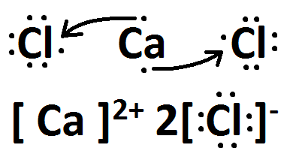
#19 _________ & ______________

PRACTICE DRAWING LEWIS DOT DIAGRAMS FOR IONIC COMPOUNDS

CHEMICAL FORMULA | LEWIS DOT STRUCTURE
KCl

NaBr

MgBr₂

AlF₃

Ca₃P₂

Part II-Metallic Bonding

Using the glossary in your textbook, define metallic bonding.
_______________________________________________________________________________________
_______________________________________________________________________________________

Page 212
#20 ___________________________________________________________________________________

#22 Malleable: _________________________________________________________________________

Ductile: _________________________________________________________________________

#23 ___________________________________________________________________________________
_________________________________________________________________________________

#25 Alloy: ____________________________________________________________________________

Uses: ____________________________________________________________________________

Alloy: ____________________________________________________________________________

Uses: ____________________________________________________________________________

Review of Ionic and Metallic Bonding
Page 214-215

# 41 ______________

#45 _____________________________________________________________________________________
_____________________________________________________________________________________

#46 _________________________________________________________________________________

#51 ___________________________________________________________________________________
__________________________________________________________________________________
__________________________________________________________________________________

#63 a. _____________________ b. _____________________

b. _____________________ c. ______________________
What did you observe?
___________________________________________________________

Page 216-217
#70
a. _______________ c. _______________

b. _______________ d. _______________

#77 __________________________________________________________________________________
__________________________________________________________________________________

#84 ___________________________________________________________________________________
__________________________________________________________________________________

#85
a. _____________ b. _____________

Pearsons SuccessNet On-line
Explore Cave Crystals by watching the video online.
Gypsum and Selenite are examples of ionic compounds having the same chemical formula.
What makes them different?
____________________________________________________________________________
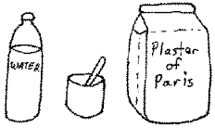

Part III-Covalent Bonding

Using the glossary in your textbook, define covalent bonding.
______________________________________________________________________________________________________________________________________________________________________________
Page 225
#2 _____________________________________________________________________________________
___________________________________________________________________________________

#5 _________________

Page 238

#12 ______________________________________________________________________________________
_____________________________________________________________________________________

#14 _____________________________________________________________________________________
__________________________________________________________________________________

#15 ______________________________________________________________________________________
_____________________________________________________________________________________

#18 ____________________________________________________________________
Page 246

#22 _____________________________________________________________________________________
_____________________________________________________________________________________

Page 253

#31 ______________________________________________________________________________________
_____________________________________________________________________________________

#34 _______________________________________________________________________________________
_____________________________________________________________________________________

#36 _______________________________________________________________________________________
_____________________________________________________________________________________

#38 ______________________________________________________________________________________
_____________________________________________________________________________________
_____________________________________________________________________________________

Page 256

#43 _________________________________

#44___________________________________________________________________________________________________________________________________________________________________________

#55__________________________________________________________________________________

_____________________________________________________________________________________

#56______________________________________________________________________

_________________________________________________________________________

#57 a. __________ b. ___________ c. ___________

Page 257
#68____________________________________________________________________________________

#75 a. ___________________________________________________________________

__________________________________________________________________

b. ________________________

c. Li &O ____________ N & O ___________ Mg & Cl __________

Page 258
#81______________________________________________________________________

_________________________________________________________________________

#85______________________________________________________________________

_________________________________________________________________________

_________________________________________________________________________

Pearsons SuccessNet On-line
Chapter 8 →8.2(Nature of Covalent Bonding) →Kinetic Art (Covalent Bonds)
Observe the molecule building of H₂, F₂, H₂O, NH₃, and CH₄ and answer questions online.

PRACTICE DRAWING LEWIS DOT DIAGRAMS FOR COVALENT / MOLECULAR SUBSTANCES
**bond type refers to polarity of the bond between two atoms. **Molecule type refers to the polarity of the entire molecule (SNAP)
Shape of molecule …choose from linear, bent, pyramidal or tetrahedral

CHEMICAL  FROMULA | LEWIS DOT  STRUCTURE | STRUCTUAL  FORMULA | SHAPE OF  MOLECULE | POLARITY  BOND TYPE | POLARITY  MOLECULE  TYPE  (SNAP)
Br₂

HF

H₂O

CF₄

NH₃

CO₂

N₂

DO YOU KNOW THE DIFFERENCE?
Using your textbook and notes from class complete the following table.

TYPES OF SOLIDS | CHARACTERISTICS OF SOLIDS
Metallic
List 3 examples:
- ____________
- ____________
- ____________

Ionic
List 3 examples:
- _____________
- _____________
- _____________

Molecular
List 3 examples:
- ______________
- ______________
- ______________

Network
List 2 examples:
- _______________
- _______________

Part IV- Intermolecular Forces of Attraction (IMF’s)

Pearsons SuccessNet On-line
Go to Chapter 8 → 8.4 (Polar Bonds & Molecules) → Kinetic Art (Polar Molecules)
Understanding Intermolecular Forces of Attractions Between Polar Molecules
Answer the questions online after you have completed the activity

Using your textbook and notes from class complete the following table.
IMF’S  INTERMOLECULAR FORCES OF ATTRACTION | CHARACTERISTICS
DIPOLE- DIPOLE
ILLUSTRATE AN EXAMPLE USING HBr :

HYDROGEN BONDING
ILLUSTRATE AN EXAMPLE USING HF :

VAN DER WAALS FORCES
(LONDON DISPERSION)
ILLUSTRATE AN EXAMPLE USING I2:

MOLECULE-ION
ILLUSTRATE AN EXAMPLE USING KCl(aq) :


Chemical bond discovered that only exists in space
July 2012 by Nicola Guttridge

There's a new bond in town, and this secret agent works best in extreme situations.
The bond, of the chemical variety, occurs in the presence of very strong magnetic fields, such as those found around ultra-dense white dwarf stars. Its discovery not only demonstrates the existence of an unfamiliar and exotic type of chemistry, it may also give insight into the behaviors of these mysterious stellar bodies.
White dwarfs are the remnant cores of low-mass stars that have exhausted all their fuel. They are thought to be the final state for most of the stars in our galaxy. Though they have masses comparable to that of our sun, white dwarfs only occupy the same amount of space as a small planet like Earth, making them incredibly dense.
They also exhibit super-strong magnetic fields on the order of 100,000 tesla – 10 billion times greater than Earth's magnetic field, and 10 million times greater than that of an average refrigerator magnet. This intense field can affect the behavior of the electrons that make up chemical bonds.

Exclusion Principle
On Earth, atoms usually bond either covalently, by sharing electrons with neighboring atoms, or ionically, via electrostatic attractions created by the transferal of electrons.
The Pauli exclusion principle governs the electrons that give rise to these bonds: two cannot occupy the same quantum state simultaneously. To avoid this scenario, electrons in bonds normally pair up in couples of opposing spin. But under the intense magnetic field of a white dwarf, "this spin interacts with the external field, acting like a little magnet," says lead author Kai Lange at the University of Oslo in Norway.
As a result, the spins of both electrons align with the external field, forcing one of the electrons to move into a different position known as an anti-bonding orbital. Normally, this would spell the end of any chemical bonds. "In a normal molecule these anti-bonding orbitals are not occupied by electrons," says Lange. "If they are occupied, the atoms are no longer bound together and the molecule breaks apart."

Unfamiliar chemistry
Lange and his colleagues wondered if things might be different around white dwarfs. "Chemistry and molecular physics become very different in the presence of a strong magnetic field," says Erik Tellgren, Lange's colleague. "Even very simple systems behave in exotic and unfamiliar ways compared to what we are used to under normal conditions."
With this in mind, the researchers used quantum chemical simulations to model chemical bonding in hydrogen and helium atoms in the magnetic field of a white dwarf. In both cases, the atoms were drawn into strongly bonded pairs.
Because the electrons in these bonded atoms occupied anti-bonding orbitals – which is forbidden in both types of known chemical bond – the researchers say this is a new type of bond. They have dubbed it "perpendicular paramagnetic bonding".
The work shows that "molecules that don't exist under normal conditions can exist in a sufficiently large magnetic field," says Lange.
David Clary of the University of Oxford, who was not involved in the study, called the research "excellent", adding "the results show that a magnetic field can stabilize molecules".

Reading the stars
Although the authors say that replicating the new bonds on Earth isn't feasible, the finding highlights how molecular chemistry may change in the presence of extreme conditions.
"I think there are probably other weird or unfamiliar types of bonding to be discovered," says Tellgren.
Such work will also help to further our knowledge of astrophysical objects like white dwarfs. By understanding how matter behaves around these objects, it may be possible to interpret their observed spectra more easily and accurately, and to better unravel what is happening in their atmospheres.

1) The new type of bond works under what type of conditions?
__________________________________________________________________________________________

__________________________________________________________________________________________

2) What does the intense magnetic field affect in the atom?
__________________________________________________________________________________________

__________________________________________________________________________________________

3) What happens normally, in an atom, when an electron enters an anti-bonding orbital?
__________________________________________________________________________________________

__________________________________________________________________________________________

4) Why did scientists use Hydrogen and Helium to simulate the bonding instead of another element?
__________________________________________________________________________________________

__________________________________________________________________________________________

Chemical
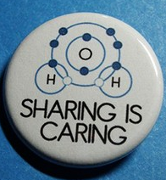
Bonding
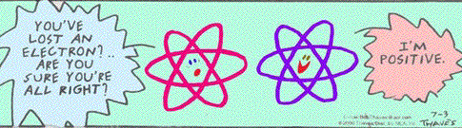
notes

Basics of Chemical Bonds
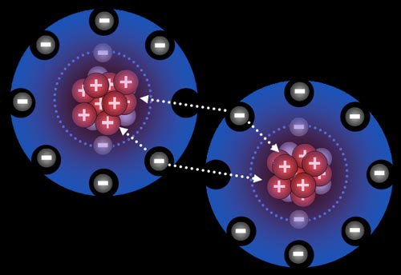
What is a chemical Bond? A simultaneous attraction by atoms for valence or “bonding” electrons.

Electronegativity & Ionization energy
are very important to determine how atoms bond.

Ionization energy ~ the energy needed to remove the most loosely bound electrons (valence electrons) in an
atom. (values found on reference table S) The greater the value the more difficult it will be to remove those valence electrons

electronegativity ~ the ability of an atom to attract electrons (values found on reference
table S) Greater the Electronegativity value the greater the ability to attract electrons

stability and bonds
atoms are always LESS stable alone than when combined or bonded. When bonded the outer Principal energy level (valence shell) has established a full number of valence electrons. (Octet)
Compounds are formed from chemically combining atoms or ions. Substances become more stable through chemical bonding, where 2 or more atoms are joined together by a simultaneous attraction for electrons.
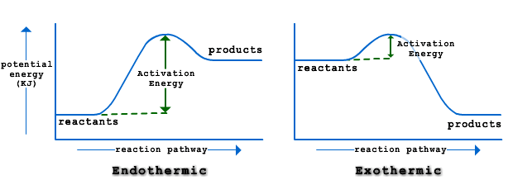

CHEMICAL BONDS

METALLIC BONDS

Bond within ONE type of Metal.

All one type of metal atoms

Electrons are delocalized among the entire metal lattice.

mobile “sea of electrons”

IONIC
BONDS

Bond between Metal & non metal

Transfer of electrons

Metals lose electrons become positive cations
Non metals gain electrons become negative anions

COVALENT BONDS

Bond between only non metals

Sharing of electrons between non metals

Molecules are covalently bonded compounds.

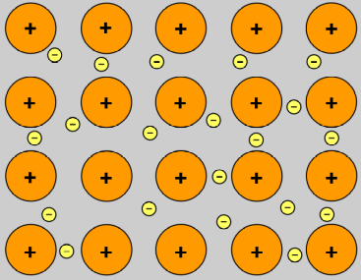
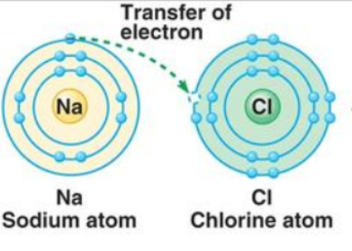
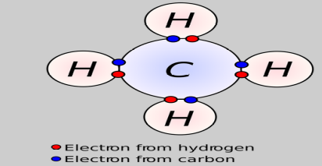

FOCUS on METALLIC BONDS

- Bonds occurring within a metal element sample.
- Made of all the same atoms
- Mobile “sea of electrons” that belong to the entire metal sample.
- Mobile electrons ~ valence electrons are able to move within the metal lattice structure (arranged pattern)
- These mobile electrons allow heat and electricity to be carried throughout the metal and are responsible for metals conductivity of heat and electricity in all phases.
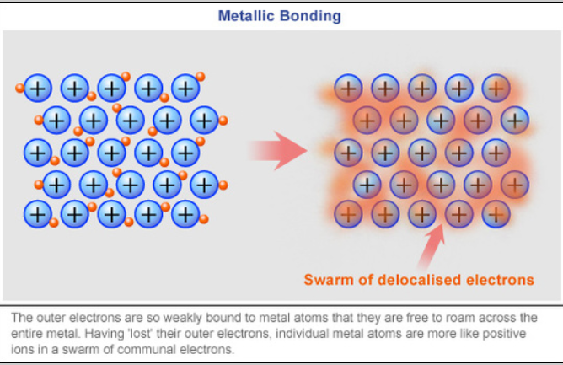

properties and characteristics of metals
  - strong substances
  - solids except mercury which is liquid
  - high melting points
  - malleable (bendable)
  - ductile (can be drawn into thin wires and metals pipes & ducts)
  - have luster (shiny)
  - thermal and electrical conductivity ALWAYS due to mobile electrons!
Representing a metallic bond

Lewis dot structures for metals include the symbol (representing the kernel of the atom and dots that represents the valence electrons.

Magnesium strip Chunk of sodium metal

Sheet of aluminum foil

FOCUS on IONIC BONDS 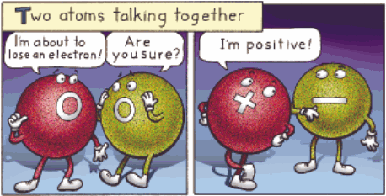

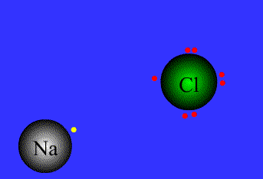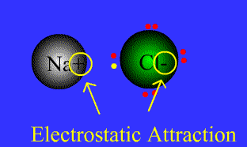
Ionic Bonds animated

- Bond between Metal & non metal
- Transfer of electrons from metals to non metals
- electronegativity difference > 1.7

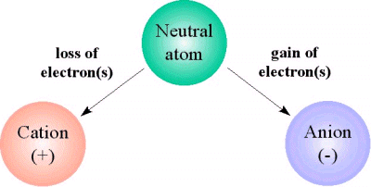
Non Metals gain electrons become negative anions
(ion is larger
than original atom)

Metals lose electrons become positive cations
(ion is smaller
than original atom)

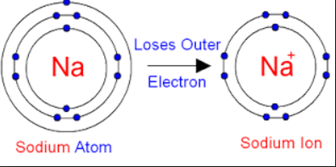
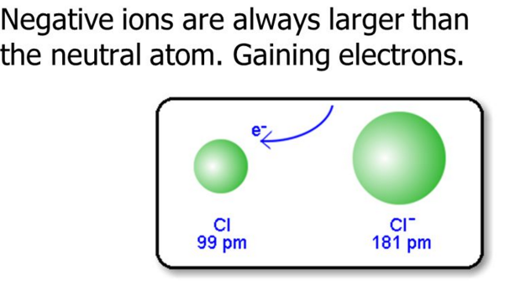

properties and characteristics of Ionic Bonds

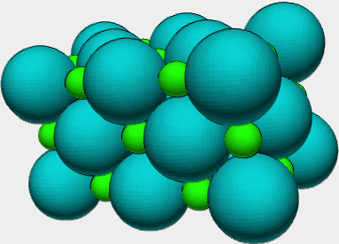
  - High melting points
  - hard crystalline or lattice structure
(definite pattern)
  - will NOT conduct as a solid BUT will conduct when dissolved or melted due to presence of free ions. Ionic solid becomes "HYDRATED" aka aqueous **remember our old friend NaCl_{(aq)}
Animation of salt dissolving in water
  - The greater the electronegativity difference between atoms the more ionic character the compound has.
Example: NaCl vs AlCl₃

Representing an Ionic bond

Lewis dot structures for Ionic Bonds include the symbol of the metal without its valence electrons and the non metals with it’s valence electron PLUS the transferred electrons from the metal. Ions are now formed and they must be represented by placing the cation and anion in brackets and placing the ion charge above the symbol.
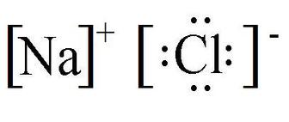
Example:

LETS TRY:
BeF₂ | AlCl₃ | CaO

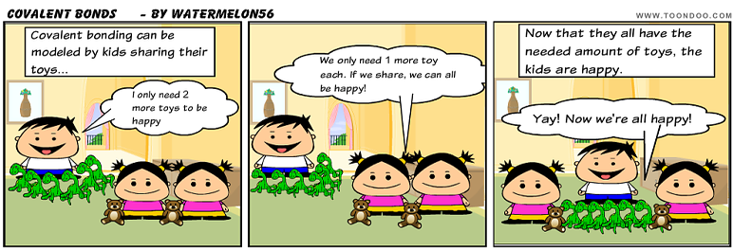
FOCUS on COVALENT BONDS

- Bond between only non metals
- Sharing of electrons between non metals
- Molecules are covalently bonded compounds.

Types of bonds Intermolecular attractions

BREAKING DOWN COVALENT BONDS

Types of covalent Molecular shapes
substances formed
Types of covalent bonds
** remember BONDS vs MOLECULE polarity!**
Symettrical Nonopolar Asymmetrical Polar
NON POLAR COVALENT  - Equal sharing (distribution) of electrons  - Electronegativity difference 0 - .4  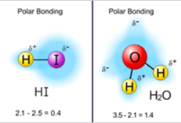 | POLAR COVALENT  - Unequal sharing (distribution) of electrons  - Electronegativity difference .5 - 1.7 (larger EN difference greater polar covalent character & greater polarity of the molecule)  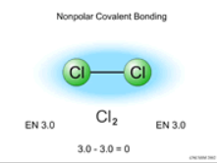
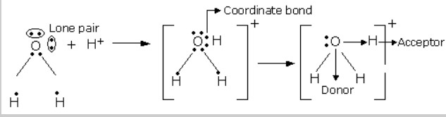
Coordinate covalent
- A lone pair of electrons are shared with an ion with no electrons to share
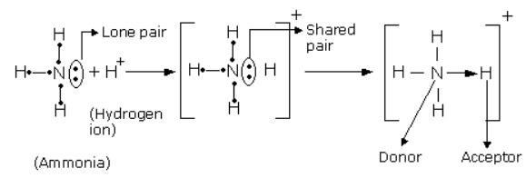
Representing a Covalent bond

Lewis dot structures for Covalent Bonds include the symbol of the non metals with their electrons and the electrons shared between elements pulled to the spaces between them.
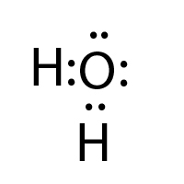
Example: Water

Lets Try These:
 | Chemical Formula | Lewis  structure | Structural diagram | Ball & Stick model
NH₃

CCl₄

CO₂

O₂

Type of covalent substance formed
Molecules are made of fixed numbers of atoms joined together by covalent bonds, and can range from the very small (even down to single atoms, as in the noble gases) to the very large (as in polymers, proteins or even DNA). They can comprise very soft materials or very hard materials when these bonds form.

Molecular Substance | Network Solid
- relatively soft substances such as water, carbon dioxide, oil, gasoline, butter  - Molecular substances tend to be gases, liquids or low melting point solids.  - Most molecular substances are insoluble (or only very sparingly soluble) in water.  - Molecular substances don’t conduct  electricity. | - very hard substances ie:  diamonds, graphite (Carbon and silicon compounds  such as sand (SiO₂)  - Network solids tend to be very  hard solids with very high melting  points.  - Network solids won't conduct  electricity.

Molecular shapes
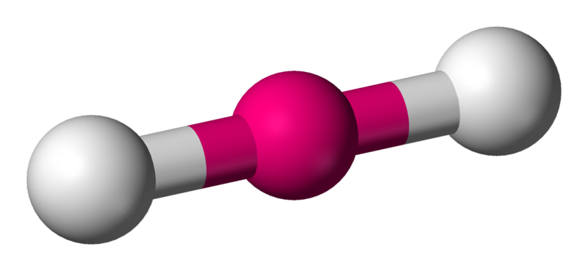  Linear | Bent  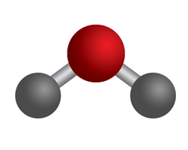
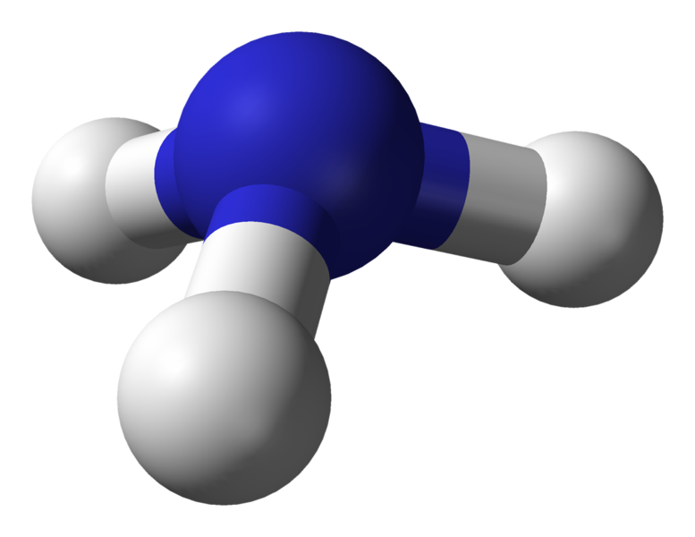  Pyramidal | 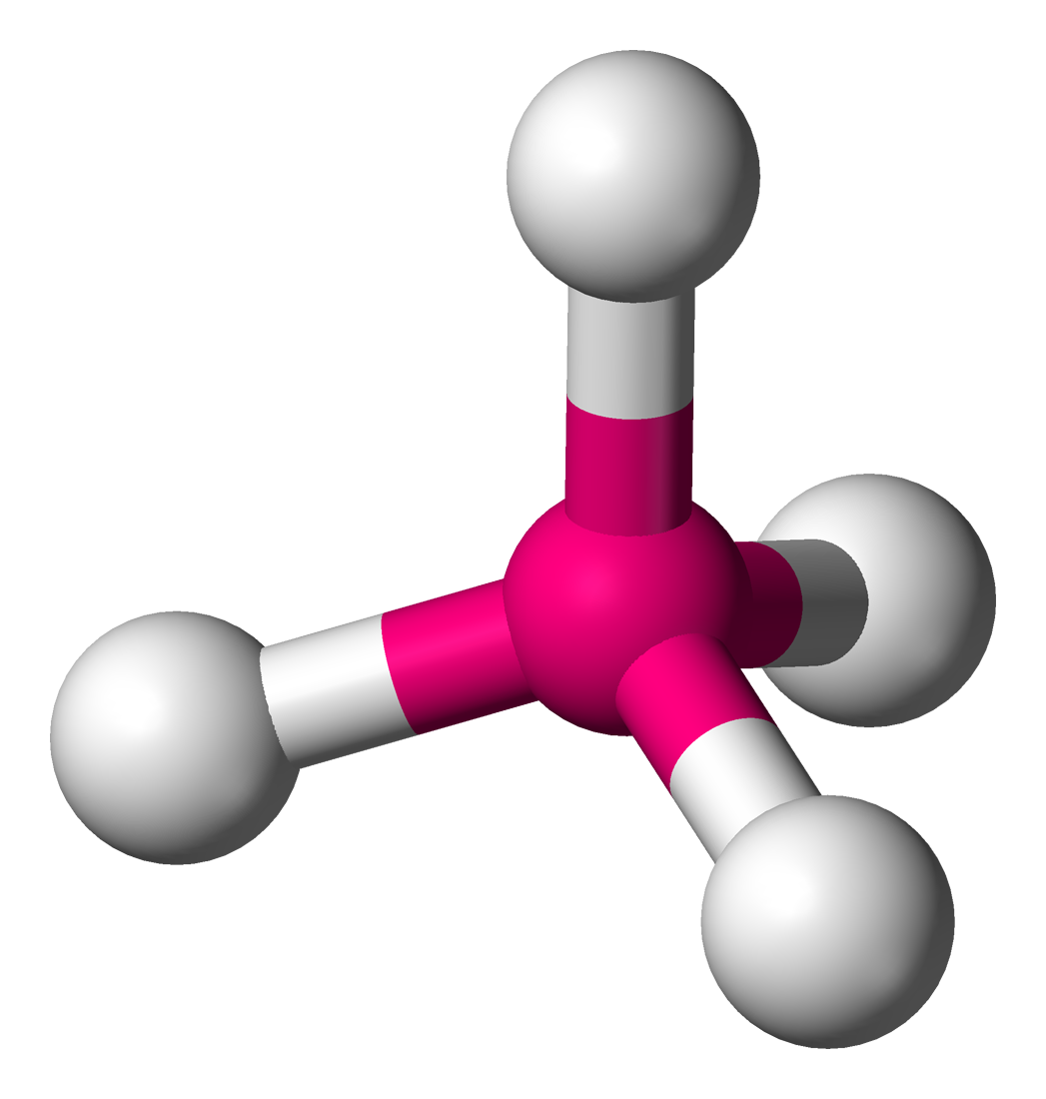  Tetrahedral
Intermolecular Forces of attractions (IMF)
Forces of attraction that take place BETWEEN molecules
Dipole – Dipole attractions  Occur between oppositely charged ends (opposites attract) of polar molecules(DIPOLES)  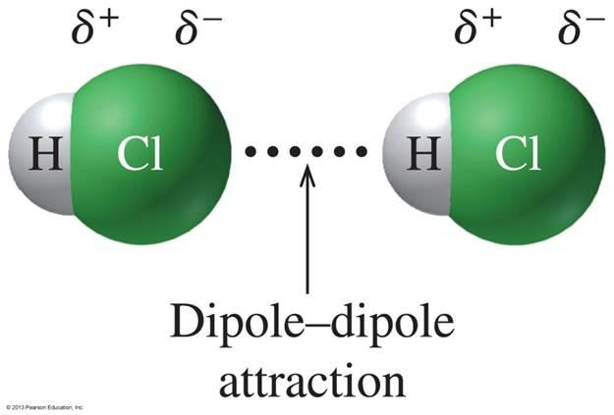 | Hydrogen Bonds  Occur between oppositely charged ends  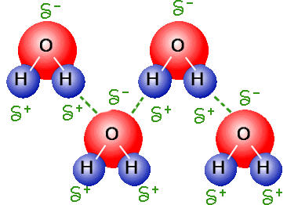  molecules that contain Hydrogen in one and Fluorine, Oxygen or Nitrogen (highly electronegative) in another (opposites attract)
Van Der Waals Forces  Weak, unusual forces that occur only temporarily between non polar molecules or between noble gases. VDW are stronger when molecules are closer & Larger  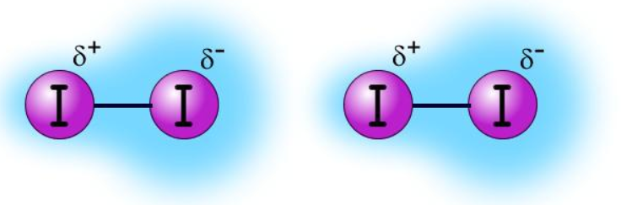 | Molecule – Ion attractions  (occurs between a molecule AND  ions from Ionic solids)  Positive end of water attracted to negative ion in ionic substance and negative end of water attracted to positive ion in ionic solid. Occurs when and ionic salt is dissolved in water.  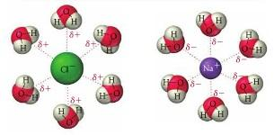

- What type of intermolecular force present for each of the following compounds?

- water _______________
- carbon tetrachloride(CCl₄) ________
- ammonia ___________
- carbon dioxide _______
- nitrogen ____________

Strengths of bonded substances

Strongest bonds weakest bonds
Network Ionic Metallic Covalent

H-Bonds, Dipole-Dipole, VDW

- List the following substances in order of increasing melting point. In complete sentences, explain the reason for your decision noting differences in bond strength.

H₂O_{(l)} NaCl_{(s)} Cu_{(s)} F_{2(g)}

LETS REVIEW…….
COMPARING INTERMOLECULAR ATTRACTIONS
Hydrogen Bonding | Van der Waals | Hydrogen Bonding | Molecule Ion attraction

COMPARING BONDS
 | IONIC | COVALENT | METALLIC
conductivity
Electron behavior
Melting point

COMPARING SOLIDS
 | NETWORK | IONIC | METALLIC | MOLECULAR
HARD OR SOFT SUBSTANCE
MELTING POINT
CONDUCTIVITY

The following is a list of characteristics of a solid substance:
substance | Conductivity | Physical characteristics | Melting point
A | Poor conductor | Hard substance | High
B | Poor as a solid, Conducts as a liquid or aqueous | Hard, solid substance | High
C | Conducts always | usually solid, has luster, malleable | High
D | Poor conductor | Soft | Low

General Review
For questions A-F choose the substance form the list below that best fits the description. Choices may be used more than once or not at all.

1. Rb₂O 2. NH₃ 3. Br₂ 4. O₂ 5. CF₄

________ (A) A nonpolar molecule with polar covalent bonds.
________ (B) An ionic substance.
________ (C) Molecule containing a double bond.
________ (D) A nonpolar molecule with nonpolar covalent bonds.
________ (E) A molecule that exhibits hydrogen bonding.
________ (F) The substance not composed of molecules.

Use the below choices to answer questions a though e. (Choices may be used more than once or not at all.)

- Fe
- Mg
- O₂
- N₂
- Mg₃(PO₄)₂
- CO₂
- H₂S
- CH₄
- NH₃
- Ne

a) electron transfer. _______________________

b) Hydrogen Bonding ____________________

c) both ionic and covalent bonds ____________

d) Contains a triple bond ____________________

e) symmetrical molecule w/ polar bonds _________

Pick the best possible answer from the choices below to answer the questions. Not all choices may be used.

- SiC
- Cu
- Cl₂
- H₂S
- CO₂
- NaCl
- K₂SO₄
- HF

a) nonpolar molecule with nonpolar bonds? ____

b) transfer of electrons? ____

c) Which has a double covalent bond? ____

d) Show Hydrogen bonds? ____

e) Which has a bent or angular shape? ____

